**The Reformed Church of Steen**

Sunday, March 30, 2025



Phone: 507-855-2336

E-mail: [steenreformed@alliancecom.net](mailto:steenreformed@alliancecom.net)

Website: [www.steenchurch.org](http://www.steenchurch.org)



**The Consistory**

Elders: Deacons: Norm Sjaarda-Vice President Dylan Bosch

Kraig Scholten Chad Rauk

Brad Bosch Chris Harnack-Chairman

Larry Bosch Tyler DenHerder

Dave Esselink Justin Maciejack

Dale Sandbulte-Clerk Kyle VanRuler

Pastor Jeremy Wiersema (712)324-1345

**Morning Service at 9:30 a.m.**

Prelude

*Welcome/Call to Worship ~ 1 Corinthians 13:13

*Mutual Greetings

*Opening Songs ~ “That’s Why We Praise Him”

“Amazing Grace/My Chains Are Gone”

Congregational Prayer

Children’s Message ~ Kilee Uittenbogaard

Dismiss 3-year-olds to Sunday School

Mission Moment ~ Simba Ministries

Ministry of Music ~ Eric Kiers

Scripture ~ 1 John 3:11-18 pg 1901

Message ~ “Love Is Not Self-Seeking”

Announcements

Offertory Prayer/Offering

Offertory Song ~ “Build Your Kingdom”

*Benediction

*Closing Song ~ “Build Your Kingdom” chorus only

*Please stand if you are able

Sunday School 10:45-11:30

RCYF at 6:00

Blanket making after the morning service. Meet in the multi-purpose room if you are willing to help.

**Bible Verse of the Month:**

**And now these three things remain:**

**faith, hope and love.**

**But the greatest of these is love.**

**1 Corinthians 13:13**

**Evening Service at 6 p.m.**

Prelude

*Invocation

Opening Songs ~Hymn #497 “Near to the Heart of God”

Hymn #486 “Faith Is the Victory”

vs 1, vs 2, chorus, vs 3, vs 4, chorus

Pastoral Prayer

Scripture ~ 2 Chronicles 20:1-15 pg 700

Message ~ “When Fear Causes Us To Over React”

Prayer of Blessing

Hymn #350 “Tis So Sweet to Trust in Jesus” vs 1-3

*Benediction

*Closing ~ Hymn #350 “Tis So Sweet to Trust in Jesus” vs 4

*Please stand if you are able

**The Lord’s Prayer**

Our Father, who art in heaven, hallowed be Thy Name.

Thy kingdom come, Thy will be done on earth,

as it is in heaven. Give us this day our daily bread,

And forgive us our debts, as we forgive our debtors.

Lead us not into temptation, but deliver us from evil;

For Thine is the kingdom, and the power, and the glory,

forever. Amen.

**The Apostles’ Creed**

I believe in God, the Father Almighty,

maker of heaven and earth,

I believe in Jesus Christ His only son, our Lord;

He was conceived by the Holy Spirit, born of the Virgin Mary,

suffered under Pontius Pilate, was crucified, dead, and buried.

He descended into hell.

The third day He rose again from the dead.

He ascended into heaven, and is seated at the right hand of God the Father Almighty.

He will come again to judge the living and the dead.

I believe in the Holy Spirit, the holy Christian Church,

the communion of the saints, the forgiveness of sins,

the resurrection of the body, and the life everlasting. Amen

***Activities for the Week***

***Tuesday: ~*** Fellowship Committee Mtg at 7:00

***Wednesday: ~*** Air Madness from 6:30-7:30

***~*** Missions Committee Mtg at 7:00

***Thursday: ~*** Women’s Bible Study at 1:30

***Announcements & Events***

There will be a special offering taken for Connor VandeVoort next Sunday morning, April 6th.

There is another sign up sheet on the Welcome Desk to bring a meal to Deb VanWyhe on Thursday afternoons for 8 weeks while she is going through cancer treatment. If you have any questions, please contact Donna Sjaarda.

**Men of Steen Church,** please consider coming to Mendistry Bible study. Posters with information about Mendistry are on the welcome desk and kiosk. We will meet weekly on Mondays, beginning April 7th from 5:45-6:30 a.m. in the consistory room. Bring a Bible and your own beverage, if desired. If you have any questions, please call or text Fred W. at 605-376-6330. Come to grow together in our Lord and in friendships.

**Open House Bridal Shower for Kenadie Fick** will be held Saturday, April 12th at 10:00 in the fellowship hall. She is registered at Target and Amazon, and is asking that you bring a recipe also.

**WOW** will be having a potluck on April 9th at noon.

**Sunday School Primary Dept.** will sing at the beginning of the morning service on Palm Sunday, April 13th. Please have your child to the primary room by 9:20 that morning.

**Easter Lilies** sign up sheet is on the Welcome Desk. They are $18. Make checks payable to Steen Women’s Ministry and give to Marilyn Jellema.

**Maundy Thursday Meal** sign up sheet is on the welcome desk.

Mission of the Month for April will be Game Plan 4 Hope supporting Loren and his family. The Mission Committee will be making subs on April 19th. Sign up sheets are on the Welcome Desk. Deliveries will be the same day unless specified on the sheet. Freewill donations are appreciated and can be given to any Mission Committee member, who are listed in the back of the bulletin and all proceeds will go to Game Plan 4 Hope to help Loren.

**Last day to sign up is Sunday, April 13th.**

** On June 19, 2024, Loren—a dedicated farmer, husband, and father—suffered a life-changing traumatic brain injury (TBI) while working on his farm. While loading cattle with his brother, one of the animals turned unexpectedly, knocking Loren down and slamming his head onto the concrete. The severity of his injuries required an emergency transfer to Avera McKennan, where he was placed in a medically induced coma for over a week. Despite doctors' optimism for his recovery with proper rehabilitation, insurance denied coverage for the specialized therapy he needed. After multiple appeals and months of hardship, Loren remains in a transitional care unit receiving minimal therapy—far less than what is medically necessary. His wife, Tammy, is fighting tirelessly to bring him home, where he can receive the care and support he desperately needs. However, their aging farmhouse was not equipped for his new reality. Adding to the heartbreak, because Loren is a farmer and owns land and farm assets, he does not qualify for Medicaid or other assistance programs. To receive the rehabilitation that could give him a chance to farm again, he would be forced to sell everything—his land, his livelihood, his legacy. That's where **Game Plan 4 Hope** stepped in. In partnership with RCM Construction, we have helped remodel their home to make it accessible. We are also providing critical medical equipment—including a patient lift, rolling shower chair, hospital bed, and lift chair—items that insurance has refused to cover. Loren's story is one of resilience, faith, and the deep challenges faced by farming families. This family has given their lives to working the land, and now, they need our support. Your prayers and generosity will directly impact Loren's recovery and help ease the burden on his wife and family.

**New Mom Meals:** We will be offering meals to families who have a new baby. Contact Amanda Metzger at 605-321-4849 about a month before your due date if you would like meals delivered after your baby is born. If you would like to volunteer to bring a meal, contact Amanda and she will add you to the list.

Equipt is now accepting enrollment for students in grades Kindergarten to Fifth grade! If you have an older student interested please reach out. You can find our online application and more information at [equiptchristianschool.org](http://equiptchristianschool.org). If you have questions please email [equipt2024@gmail.com](mailto:equipt2024@gmail.com) or call 507-283-7875. We are hopeful to order curriculum before June 1 to qualify for great discounts. If you are considering, please reach out today.

**Inspiration Hills Summer Camp** registration is currently open. Brochures are available in the fellowship hall. For more information or to register, go to inspirationhills.org. The church will pay for a student and one friend.

**“Common Grounds” Coffee**: Help yourself to a self-serve coffee bar before church.

**Hope Haven’s Annual Benefit Auction** is back and better than ever. Join us Friday, April 4th at Te Slaa Trucking in Hull, Iowa for an unforgettable evening filled with excitement, incredible items and the opportunity to make a difference. Doors open at 5:00 p.m. with a silent auction, followed by an action-packed live auction at 5:30. With over 450 items to bid on—including a John Deere lawn mower, Youth ATV, Traeger, Royal Enfield Motorcycle, LuxCraft glider chairs and much more-there’s something for everyone. Plus, don’t miss our **Sponsor a Wheelchair Auction,** supporting individuals with disabilities in developing countries, giving them the gift of mobility and independence. Visit **hopehaven.org** to browse the catalog and learn more. Don’t miss this chance to make a meaningful impact through Hope Haven’s largest fundraiser of the year!

SW MN Pro-life group will hold their annual Pro-Life Spring Rally on Monday, April 14th at 7:00 p.m. at S.W. Christian High School: 550 Elizabeth St., Edgerton, Mn.

The speaker will be Carrie Meyers, executive director of Choices Pregnancy Center in Marshall & Redwood Falls. Carrie will be sharing her personal story of how she got involved & what the Pregnancy Center does to help women with an unplanned pregnancy. Please come to support this worthy cause.

Join New Roots Ministry on a Saturday between May--October for a 5-hour session of Everyday-Ambassador Practicum. Yep, it's about learning to more often, and more effectively, share what is so dear to us--God's good news. Read about this at <http://sfnewroots.com/our-ministries>.

**Lyon County Food Shelf needs:** "child friendly" items such as soup, crackers, canned fruit, fruit cups, and juice pouches.

**A Note From the Librarian:** The featured book is

"God’s Mysterious Ways". There are lots of new books to check out and still some free books on the cart. ****We are asking that kids be supervised as there have been repeated messes in the library.

***Opportunities to Serve the Body of Christ***

**This Week Next Week**

|  |  |  |
| --- | --- | --- |
| Organist | Kids Praise Team | Praise Team |
| Ushers | Justin Esselink  Eric Uittenbogaard  Trevor Paulsen | Chase Bosch  Marlin Elbers  Dave Spykerboer |
| Nursery | Amanda Rozeboom  Kelsey Baker  Jackson Gacke | Stephanie Roozenboom  Hadley Roozenboom  Sage DeBoer |
| Greeters | Erwin & Janet Bonestroo  Mitch & Molly Bonestroo | Gustavo & Sidney Bonilla  Dustin Bonnema |
| Children’s  Message | Kilee Uittenbogaard | Eunice Roozenboom |
| Camera | Sawyer Bosch | Ryker Gehrke |
| PowerPoint | Chase Bosch | Justin Esselink |
| Sound | Tim Bosch | Joshua Wiersema |
| Coffee | Angie Sjaarda |  |
| Ministry of  Music | Johanna VanderSteen | Tom & Dolly VanDerWeerd |



* Those that are homebound and in nursing homes:

Anna Mae Berghorst, John Bosch, Rich VanDerBrink and Lucy VanWyhe.

* Those in our church and community who are dealing with cancer: Marv Albers, Doug Boeve, Erwin Bonestroo, Heather Johnson, Pete Kracht, Shane McMath, Seth Rozeboom, Robert Sandbulte, Merle Sandstede, Starla Scholten, Rick Tatge, Deb VanWyhe, Sheila Vis and Ivan Wiersema.
* Connor VandeVoort as he heals from his heart transplant.
* The vacant churches of the Alliance of Reformed Churches.

Sermon Notes

Selfish love is not real love.

Matthew 16:24 – “Then Jesus said to his disciples, whoever wants to be my disciple must deny themselves and take up their cross and follow me.”

Matthew 20:26-27 – “It shall not be this way among you. Instead, whoever wants to become great among you must be your servant, and whoever wants to be first among you must be your slave.”

Three things that real love requires:

1. Reject the example of Cain’s self-importance.
2. To battle our own human nature.
3. Re-think what it means to be a Christian.

Jesus, the example that each of us need to follow:

Love others with action and in truth

Lay down our life for one another

**Consistory Meeting**

**March 24, 2025 at 8:25 p.m.**

Members present were: Pastor Jeremy, Justin Maciejack, Kyle VanRuler, Chris Harnack, Tyler DenHerder, Dylan Bosch, Chad Rauk Norm Sjaarda, Dave Esselink, Kraig Scholten, Brad Bosch, Larry Bosch and Dale Sandbulte. A quorum was present.

Brad Bosch let opening devotions from 1Corinthians 13:7, Code of Contentment and opened the meeting with prayer.

The minutes of the February 17, 2025 regular meeting were read for information.

**Youth Ministry:** Dylan made the motion, support by Brad, to leave RCYF on Sunday. MSC.

**Mission Committee:** Asking for possible support for Megan DeRuyter as missionary before congregational meeting.

**Christian Education:** Discussion about Midweek material. Awana? Gems and Cadets?

**Property:** Bell and brick work will need to be redone at some point.

**Financial Reports:** General Fund: $50,207.34.

Benevolent Fund: $35,044.58

Building Fund: $16,194.20

building fund loan was paid off

MSC to approve reports.

**New Business:** MSC to serve supper before Maunday Thursday service. MSC to have a special offering for Connor VandeVoort. Brooke VanEssen has asked for support for new Christian school in Luverne.

The minutes of tonight’s meeting were read. MSC to approve minutes as read. MSC to adjourn. Prior to adjournment, Kyle VanRuler closed with prayer. The next consistory meeting will be April 21, 2025.

If you need to contact the church secretary, Tammy Bos, you can do so by email, [steenreformed@alliancecom.net](mailto:steenreformed@alliancecom.net), by calling the church during her posted office hours, or by calling/texting her at 605-951-8254. Thank you!

This week’s office hours ~ Monday 9:00-12:00

Tuesday 9:00-12:00

Wednesday 9:00-11:00

Friday 9:00-12:00

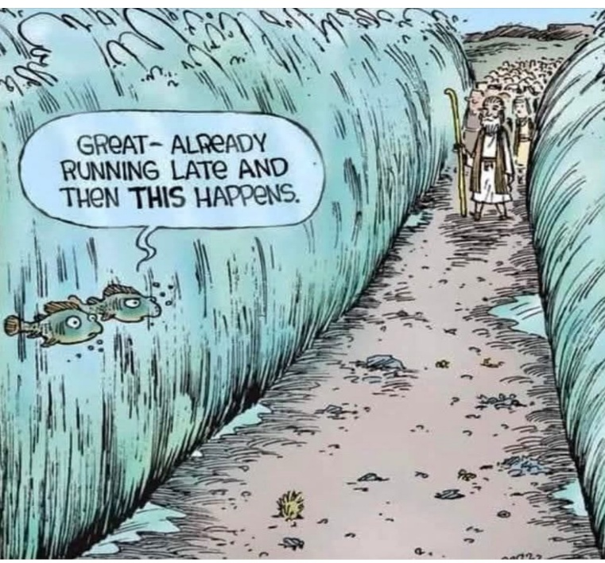



March 31 – Lorraine Sandbulte

April 1 – Norm Sjaarda

We are updating birthdate records so if you started coming to church here in the last 5 years, please let Tammy know.

General Fund: Dylan Bosch

Building Fund: Tyler DenHerder

Benevolent Fund: Chad Rauk

Sunday School Superintendent: Dale Sandbulte

Midweek Superintendent: Rex Metzger

Organists/Pianists: Lisa Kiers, Kendra Paulsen, Lorraine

Sandbulte, Glenda Sandstede, Debbie Tilstra

Midweek Meal Supervisor: Dolly Van Der Weerd

RCYF Sponsors: Tyler & Kala Bush, Greg & Laura Leenderts,

Eric & Kilee Uittenbogaard

Missions Committee: Chairman-Dave Tilstra,

Treasurer-Nicie Bosch

Sidney Bonilla, Tyler Bush, Annette Elbers, Jodi Harnack,

Eric Kiers, Sadie Knobloch, Kendra Paulsen,

Eric Uittenbogaard, Dolly Van Der Weerd

Steen Women’s Ministry: President-Amanda Wiersema

Vice President-Janice Klosterbuer

Treasurer-Marilyn Jellema

Fellowship Committee: Annie Bos, Larry Bosch, Troy Bosch,

Stephanie Roozenboom, Dale Sandbulte

Church Decorating Committee: Vonda Klarenbeek,

Holly Mulder, Glenda Sandstede, Donna Sjaarda

Library Supervisor: Kendra Paulsen

**In case of any cancellations, you will receive a phone call from the church.